Chapter 15, Solution 20.

Using Fig. 15.32, design a problem to help other students to better understand the Laplace transform of a simple, periodic waveshape.

Although there are many ways to solve this problem, this is an example based on the same kind of problem asked in the third edition.

Problem

The periodic function shown in Fig. 15.32 is defined over its period as

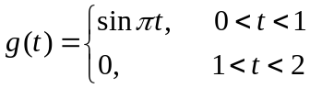

Find G(s).

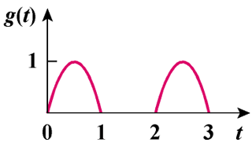

Figure 15.32

Solution

Let 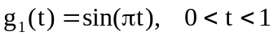
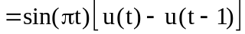 0 < t < 2
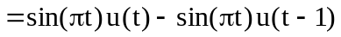

Note that .
So,

